People With Disabilities Foundation cordially invites you to attend our free seminar:


Understanding Employment Issues for People with Psychiatric and/or Developmental Disabilities
Topics include: Most common disorders in the workplace, reasonable accommodations, employment as part of recovery, veterans’ issues, update on ADA amendments and the Mental Health Parity Act from 2008.

An open public discussion
Audience: The general public; people with disabilities, their families and friends; HR managers; vocational rehabilitation providers; veterans; social service providers; and the legal community.

Friday, May 15, 2009, 1:00-4:00PM
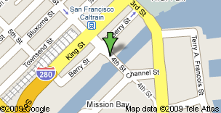
Mission Creek Adult Day Health
Swift Conference Center (3rd floor)
930 4th St. (cross street is Berry Street)
San Francisco, CA 94158
Use of public transportation encouraged, as street parking
may be difficult. Transportation lines include CalTrain, Muni trains
N-Judah and T-Third, Muni bus lines 10, 30, 45, and 47

Speakers
Claudia Center, Esq., Senior Staff Attorney, Legal Aid Society - Employment Law Center, San Francisco. Ms. Center represented Barnett in US Airways, Inc. v. Barnett, 535 U.S. 391 (2002), before the U.S. Supreme Court, a case that helped clarify the scope of “reasonable accommodations” for disabled employees.
Janice E. Cohen, M.D., Psychiatrist, San Francisco. Dr. Cohen is a past chair of the Mental Health Section of the American Public Health Association (APHA) and a member of the American Association of Community Psychiatrists (AACP).
Anita Gilbert, Ph.D., Psychologist, San Francisco. Former California Department of Corrections and Rehabilitation psychologist and Medical Director of Walden House, San Francisco.
Dan Daniels, Assistant Program Director, Buckelew Employment Services, San Rafael.

Expertise in assisting adults with mental illness in securing and maintaining employment and
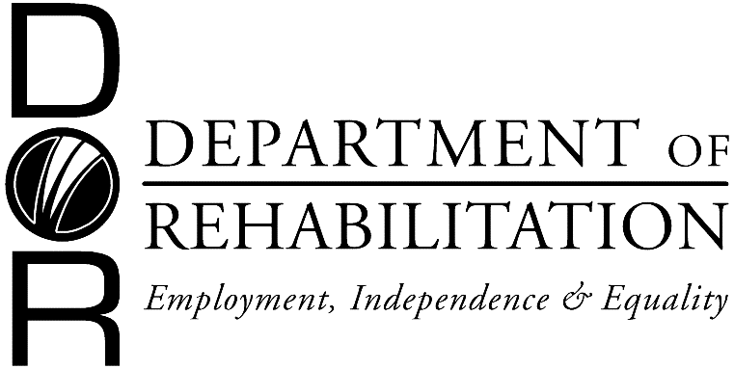
liaising with community employers
Moderated by People With Disabilities Foundation
Master of Ceremonies: Darlene Rutkowski, District Administrator,
CA Dept. of Rehabilitation, San Francisco.

FREE ADMISSION
(tax-deductible donations are appreciated)

TO RSVP OR FOR MORE INFORMATION, PLEASE CONTACT EDUCATION@PWDF.ORG OR (415) 931-3070
3 Hours of continuing education credits from the State Bar of California (MCLEs), California Board of Behavioral Sciences, and 2.75 Credit Hours from the Commission on Rehabilitation Counselor Certification (pending approval).

Anyone needing a signer please call Spencer Williams at (415) 931-3070 by May 1, 2009.

Next Seminar: Health Care Issues for People with Mental and/or Developmental Disabilities

